**HTML RESEARCH**

**1. What are semantic tags in HTML, and why are they important?**

Semantic tags or semantic elements give a clear meaning both to the browser and the developer. Examples of semantic tags can be <header>, <main>, <form>, <table>, <article>, etc.

Semantic elements define the content in the tag itself. For instance, if we wrote <section>, that would clearly outline a section. If we included <footer> that would clearly outline the footer of the page.

Semantic tags are important because they make HTML more comprehensible by creating a clear distinctions not only in the layout, but also in the content and between sections of a webpage. Furthermore, semantic tags also help define the role and relative importance of each section.

Semantic = meaning.

*\*Examples of non-semantic tags are: <div>, <span>.*

Semantic tags are very important because they help also the search engines to determine the importance and context of a web page.

Cheat sheet:

|  |  |
| --- | --- |
| **Tag** | **Description** |
| <article> | Defines independent, self-contained content |
| <aside> | Defines content aside from the page content |
| <details> | Defines additional details that the user can view or hide |
| <figcaption> | Defines a caption for a <figure> element |
| <figure> | Specifies self-contained content, like illustrations, diagrams, photos, code listings, etc. |
| <footer> | Defines a footer for a document or section |
| <header> | Specifies a header for a document or section |
| <main> | Specifies the main content of a document |
| <mark> | Defines marked/highlighted text |
| <nav> | Defines navigation links |
| <section> | Defines a section in a document |
| <summary> | Defines a visible heading for a <details> element |
| <time> | Defines a date/time |

**2. HTML Validation: Explore the importance of HTML validation and how it can help ensure well-formed and error-free web pages. Provide a small contextual example.**

HTML validation is the process of checking a web page's HTML code. By doing so, it ensures the HTML code follows proper syntax, adheres to the best practices and follows the correct format. Validating HTML is crucial for several reasons:

1. Cross-browser Compatibility: Valid HTML is consistent across different web browsers versus invalid HTML where different browser can interpret the code differently, leading to inconsistent layouts and functionality issues.

2. Accessibility: valid HTML promotes accessibility to people with disabilities. It assures that the code can be properly interpreted by assistive technologies such as screen readers.

3. Search Engine Optimization (SEO): Search engines prefer well-structured and semantically meaningful HTML. Valid HTML contributes to better search engine rankings by providing clear cues to search engine crawlers or bots about the content and structure of the web page. Simpy put, pages with correctly implemented semantic HMTL have an advantage in SEO over those that don’t.

4. Future-proofing: Valid HTML is more likely to be compatible with future web standards and technologies. It almost guarantees that your website remains functional as new browsers and devices are developed.

Here's a small contextual example about the importance of HTML validation:

Let’s say I am building a simple webpage for a blog post about healthy eating habits. And the code looks like this:

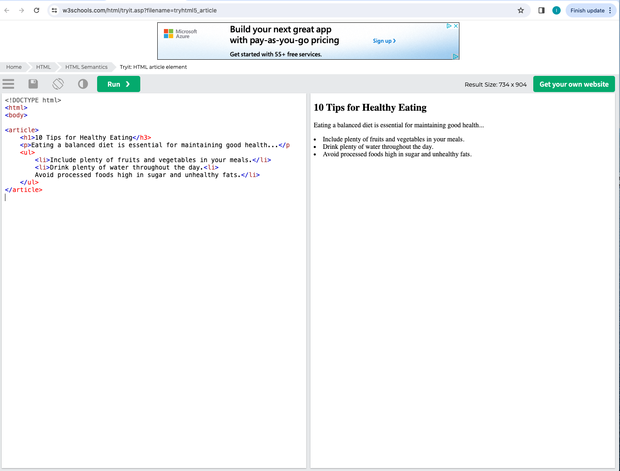

In this example, the header appears to be ok and the unordered list also appears to be ok. Nevertheless, with a proper HTML validation we would find that <h1> needs to close with an </h1> tag and not </h3> and the 2nd item on the under list should have a closing tag </li> as well as an opening <li> tag for the third item on the list..

The proper code should look like this:

<article>

<h1>10 Tips for Healthy Eating</h1>

<p>Eating a balanced diet is essential for maintaining good health…</p

<ul>

<li>Include plenty of fruits and vegetables in your meals.</li>

<li>Drink plenty of water throughout the day.</li>

<li>Avoid processed foods high in sugar and unhealthy fats.</li>

</ul>

</article>

Summary: HTML validation is a critical step in web development, ensuring that web pages are well-formed, error-free, accessible, and compatible with different browsers and devices.

**3. Explore the role of meta tags in HTML for SEO. Research common meta tags such as <title>, <meta name="description">, and <meta name="keywords">. Investigate their impact on search engine rankings and best practices for optimizing them.**

Meta tags are elements in the HTML code that are not visible to the user but they play an important role within the SEO performance.

The most used meta tags are <title>, <description>, <robot>, <refresh>.

Meta <title>:

This tag clearly outlines the title or subject of the page. Title tags affect your SEO because google robots use them to understand how relevant they are to your search. Title tags determine how successful you will be in beating the competition in search engine result pages.

<Meta name=“description”>:pretty self explanatory this meta tag informs the search engine with a summary of what the website is about. Usually a snippet of text that describes the content.

<meta name=“keywords”>: another self explanatory meta tag includes keywords that could be found in the website. What is relevant to make a distinction is that these keywords are written in the code itself and not only in the visible page. For instance, if I had a meta tag:

<meta name=“keywords” content=“antique instruments”/> anybody searching for antique instruments would most likely get to see my page first that even websites that do sell antique instruments but did not include a meta tag in their code.

Sources:

<https://www.w3schools.com/html/html5_semantic_elements.asp>

https://www.simplilearn.com/tutorials/html-tutorial/html-semantics#:~:text=define%20its%20content.-,Why%20Do%20You%20Need%20to%20Use%20Semantic%20Tags%20in%20HTML,are%20much%20easier%20to%20read.

<https://developers.google.com/search/docs/beginner/seo-starter-guide>

<https://developer.mozilla.org/en-US/docs/Learn/Tools_and_testing/Cross_browser_testing/Introduction>

<https://www.sistrix.com/ask-sistrix/onpage-optimisation/what-is-html-validation#:~:text=HTML%20validation%20is%20a%20check,make%20corrections%20before%20testing%20again>.

<https://www.conductor.com/academy/what-are-meta-tags/#what-are-html-meta-tags>

<https://www.semrush.com/blog/title-tag/?kw=&cmp=US_SRCH_DSA_Blog_EN&label=dsa_pagefeed&Network=g&Device=c&utm_content=671195364152&kwid=dsa-2185834090056&cmpid=18348486859&agpid=156019556362&BU=Core&extid=97592280295&adpos=&gad_source=1&gclid=CjwKCAjw_LOwBhBFEiwAmSEQARMzThQWMrfnneVOHafJ_xxrZVp3qT3J7AFQt15uG1Rp3DLHbcB_mBoCCZgQAvD_BwE>

<https://developer.mozilla.org/en-US/docs/Web/JavaScript>